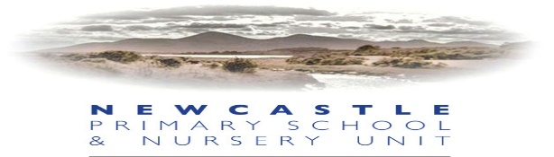

Monday 29th June 2020
Dear Parents/Guardians
As a group of Primary Principals in the immediate locality, we have had a series of meetings to discuss the way forward and laterally the implications of the Department of Education publication, ‘Northern Ireland Re-Opening School Guidance: New School Day’, issued Friday 19th June 2020. With due regard given to the pastoral care of our pupils, staff and indeed the parent body we have reached a consensus which we would like to communicate with you:
- We will reopen for pupils on Monday 24th August for a P2-7 induction week which will focus on the pastoral needs of our pupils, their health and wellbeing and the enhancement of a ‘reconnect’ between pupil and school, helping our pupils settle back into the new school day and the changes to their school environment.
- Various patterns for reopening are being discussed. We will communicate with you the most viable options. However, as Principal I am aware that the situation remains subject to change, if for instance, social distancing requirements are amended. Pupils will most likely attend on a Monday/Tuesday or Thursday/Friday with the school closed on Wednesday for deep cleaning before the changeover.
- Arrangements regarding staggered arrivals/collections will be necessary and details will be communicated to you. All parents will be asked to remain outside school buildings to reduce footfall and the potential spread of the virus.
- Pupils are asked to wear full school uniform as normal each day they are in school. We would ask you to ensure uniforms are washed regularly throughout the week.
- School bags and lunch boxes/bags should not be brought into school. Parents will be asked to provide pencils, colouring pencils etc. which will remain in school and stored only for the individual pupil’s use.
- Pupils eligible for free School meals (FSM) will have a packed lunch provided by the catering staff. All other pupils should bring a packed lunch to school. Please note there will be no FSM packed lunches on the week commencing 24th August; this will commence from 1st September.
- Packed lunches must contain items that the pupil can open and eat independently and be in a disposable bag.
- The school staff will be reinforcing the good practice that you are undertaking at home, to educate your children in the necessary measures for minimising the spread of the virus, e.g. ‘Catch it, Bin It, Kill It’, thorough handwashing and maintaining social distance.
- It is your responsibility to access and follow school communications e.g. Website, school app or Facebook. Please ensure that you regularly check the school website for updates.
Please be aware that this information is subject to change in light of evolving DE Guidance. As a group of local principals we will continue to meet over the summer to explore how the needs of our pupils will be met and yet remain compliant with Department of Education and Public Health Authority Guidance. The NPS staff will be back in school from Monday 17th August and we will communicate more information to you that week.
May I take this opportunity to thank you for your support and your kind words over the past three months and wish you all a restful, safe and healthy summer break.
Yours sincerely,
Mrs J McCann
Principal

