January 2022 News
Welcome back to the new term at NPS!
Once again we are facing daily challenges with regards to Covid-19. If your child is unwell, please keep them at home and seek medical advice. We will endeavour to keep school open at all times but if Covid-19 cases rise amongst pupils and staff we may be left with no alternative but to resort to remote learning for some classes. Your continued understanding and support in the face of ongoing Covid-19 cases, unavoidable staff absence and a shortage of substitute teachers is appreciated. Any decision to move a class or classes to remote learning will only be taken where cover is unavailable and all other options have been exhausted.

Applying for a Pre-school or Primary 1 Place for September 2022
The online citizen portal opens on Monday 10th January 2022 at 12 noon for Pre-school and Primary 1 applications. Log on to www.eani.org.uk/admissions to apply. Application deadline Friday 28th January 2022 at 12 noon.

P7 swimming lessons commence on Wednesday 12th January 2022 for 5 weeks. The cost remains at £3.50 per session and should be paid through the school money app.
P7 Confirmation on Friday 11th February 2022 at 2pm.
School closes for half-term break on Tuesday 15th February at 1.15pm. Last day of term for Nursery is Monday 14th February 2022; usual times apply.
Monday 21st February 2022 – School Development Day, pupils need not attend.
Tuesday 22nd February 2022 – School recommences for the Spring Term.
Upcoming events
Monday 14th March 2022 – P3 First Confession, 2pm.
Thursday 17th March 2022 – St Patrick’s Day, school closed.
Friday 8th April 2022 – school closes at 12 noon for the Easter break.

Information for parents of pupils starting Nursery, P1 or Year 8 in September 2022.
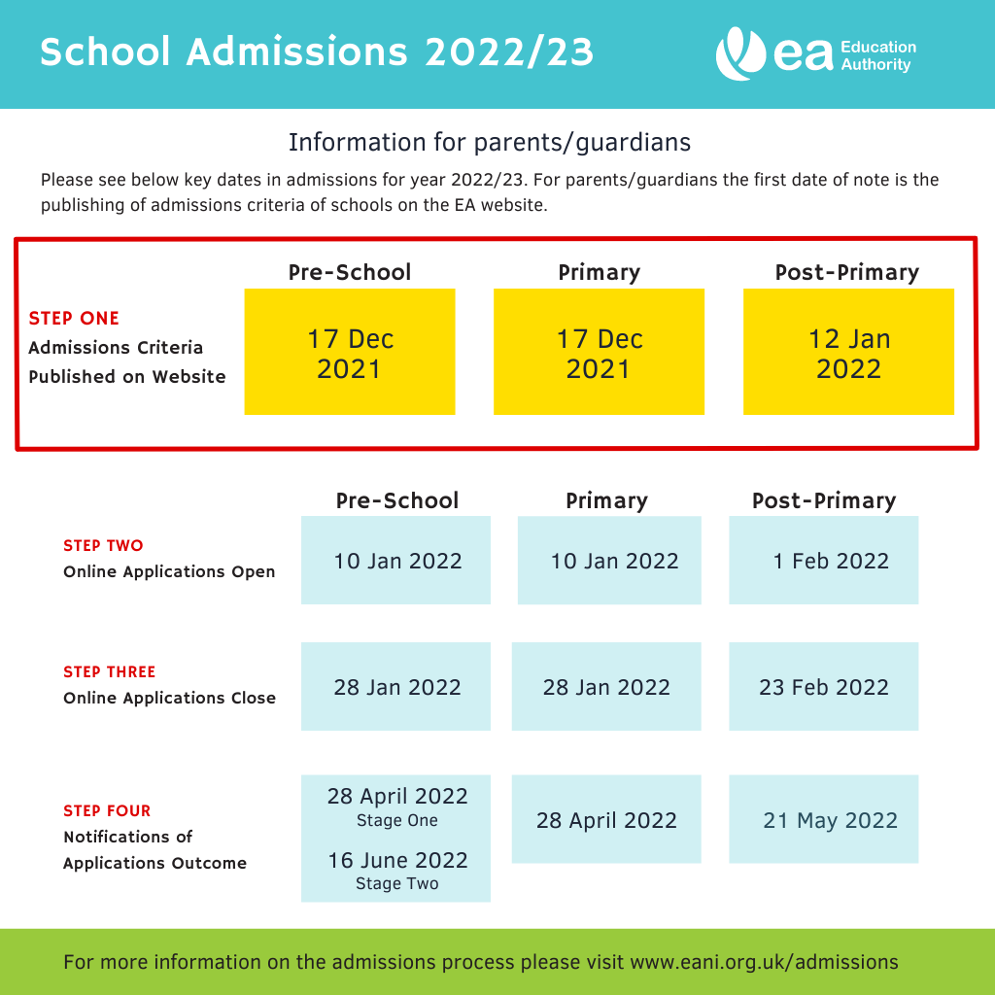

Please keep up to date with school news on the school website www.newcastleps.com

